Josh Gibson Lab Work

03/02/26 Lab
I went to my individual workspace and created two folders, one called ArchOSC Assignment for my work and the other called Pictures for any photos/screenshots I take. I then screenshotted my work, pasted it into paint and saved it in my Pictures folder and called it Photo 1.
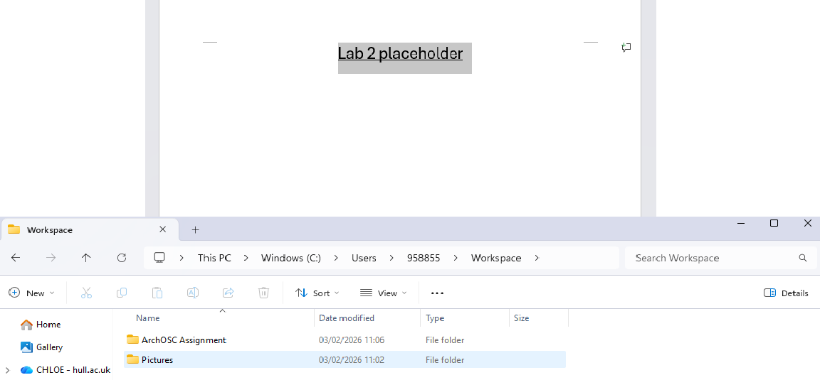

I created a local repository using the git init command in the terminal in my workspace folder. I then created a repository on GitHub called ARCHOSC-Assignment-ChloeStaples that I can push my local repository into.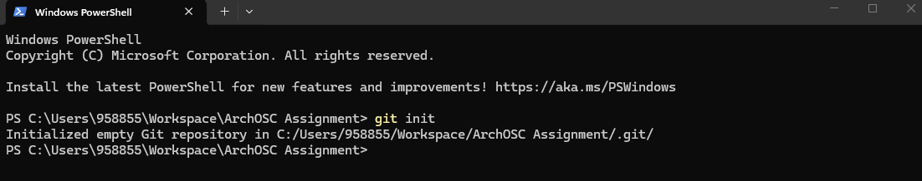

I copied and pasted the code from the work area into Visual Studio Code and changed the “insert your name here” part to my name.
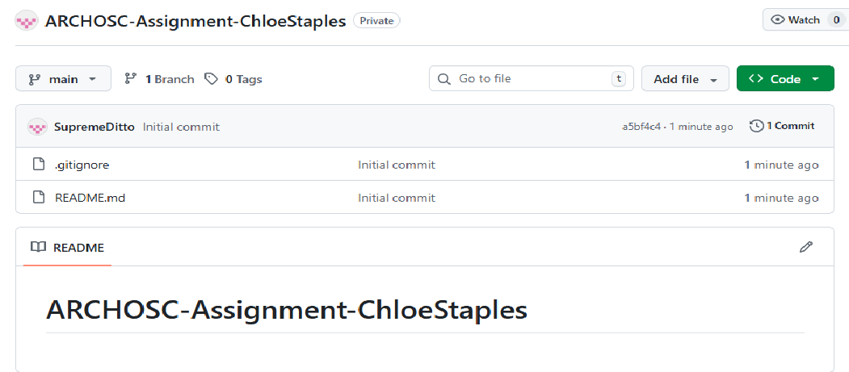

I then pulled my work from GitHub into my local repository so that I knew how to access my work.
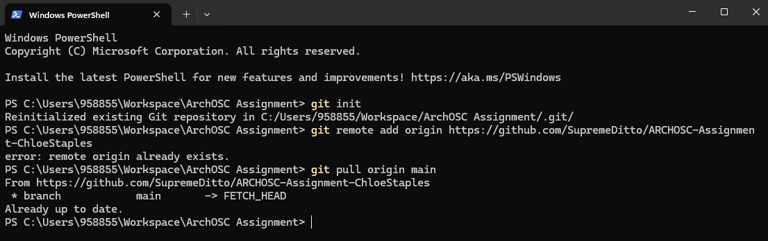

Using Visual Studio Code, I created a basic website that I will be building off of in later lab sessions. I then used GitHub Pages to launch the website off.
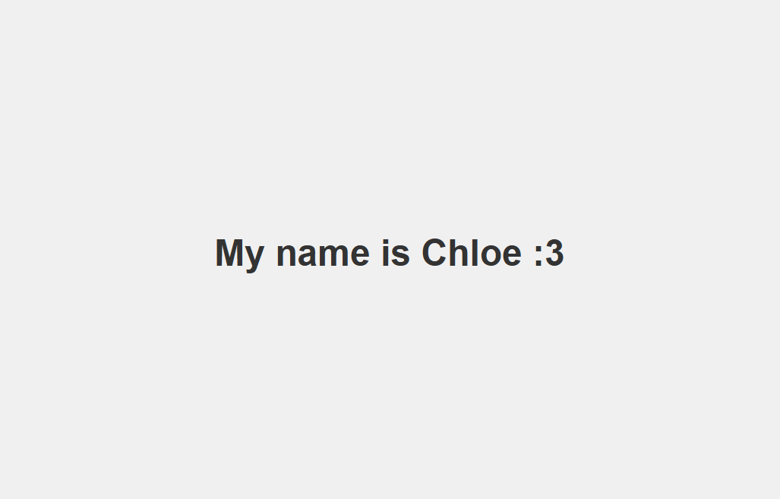

10/02/26 Lab
I accepted the assignment and to put the documents into this repository, I used the terminal to add my old repository to the “Original Assignment” folder in my workspace and dragged and dropped the work into my new repository. I then opened the terminal in the “New Assignment” folder and added my new repository and its contents into the folder.
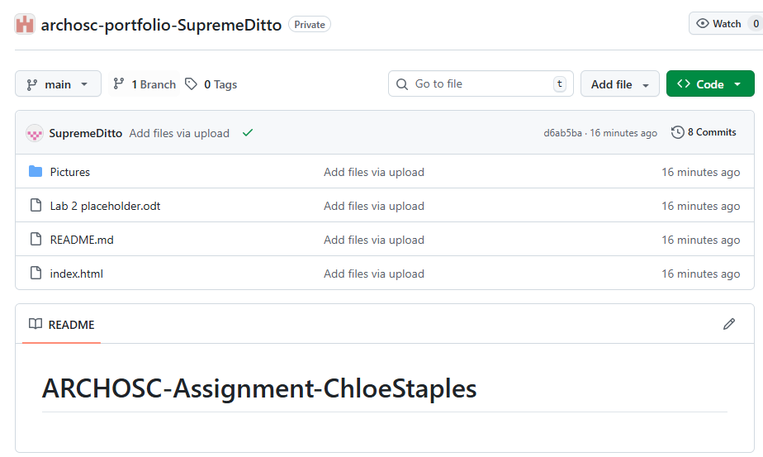

Next, unpublished my website and I set up a GitHub Actions Pipeline. I did this by following the CICD pipelines and setting up and creating my own workflow to build from. I then wrote out the YAML used in the lab work sheet.
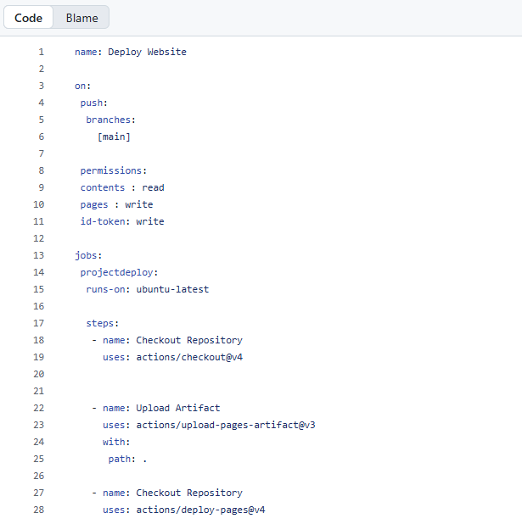

17/02/26 Lab
First, I pulled my work from GitHub into the folder I created in the workspace area. Then using Visual Studio Code, I created my style sheet and JavaScript files.
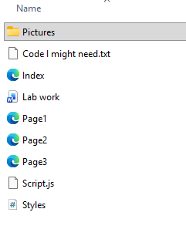
I then added links to my style sheet and JavaScript on all of my other website files.
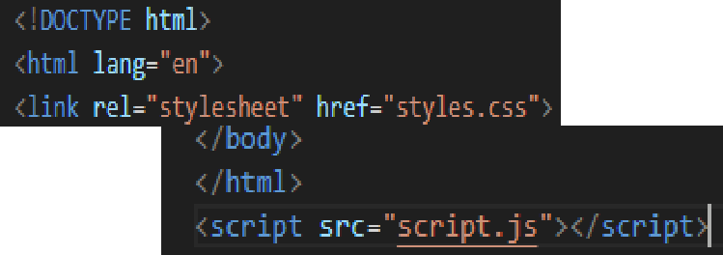

I created some of the pages I would need but I didn't know how to link them to each other, so I Used W3Schools to figure out how to do it.

W3Schools is very useful and it's what I'm mainly using when I can't figure out how to do something, like adding pictures to my website.
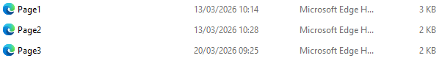

Here is a screenshot of what my home page currently looks like.
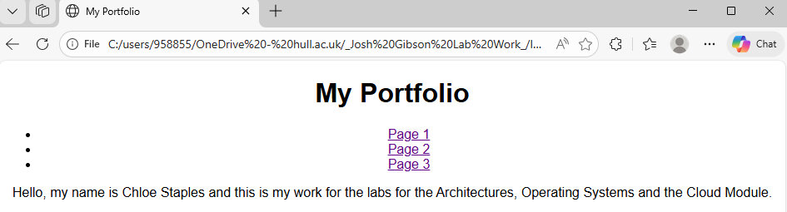

I changed the colour of my text to orange so that I knew my style sheet was working properly. I would've changed the text so everything was a different colour like the example in the lab but I wanted to make sure the style sheet was working as intended.
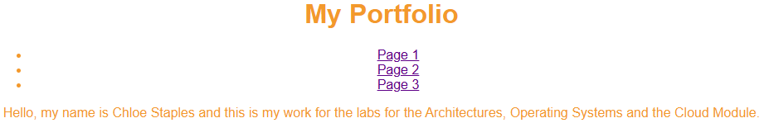

I then created a dark mode for my website. It is just a black background with white text, but it gets the job done.
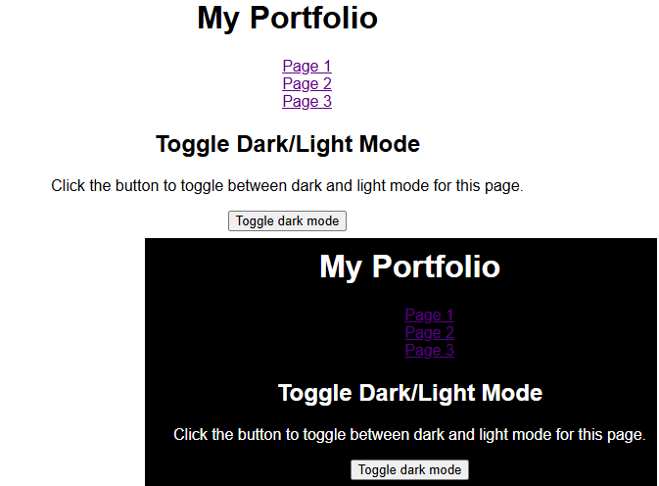
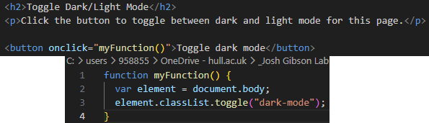

24/02/26
Quick disclaimer! It appears some of my pictures have gone, and I can't find them, so from this point on, I have done the work, but I don't have the photos anymore to prove it. Sorry!
First, I opened the first virtual machine and checked if Git was installed on it. It wasn't, so I used this link https://git-scm.com/download/win to install it, then I got it set up so it would work correctly.

I then created a folder called "Deployment" and cloned my portfolio into it.

So that my website could be viewed on the virtual machine, I used the command "Get-Service w3svc" in the terminal to get the "wwwroot" folder. I cut and pasted the two items that were already in the folder onto my desktop, then copied and pasted my website in the folder, where I could open it on my browser.
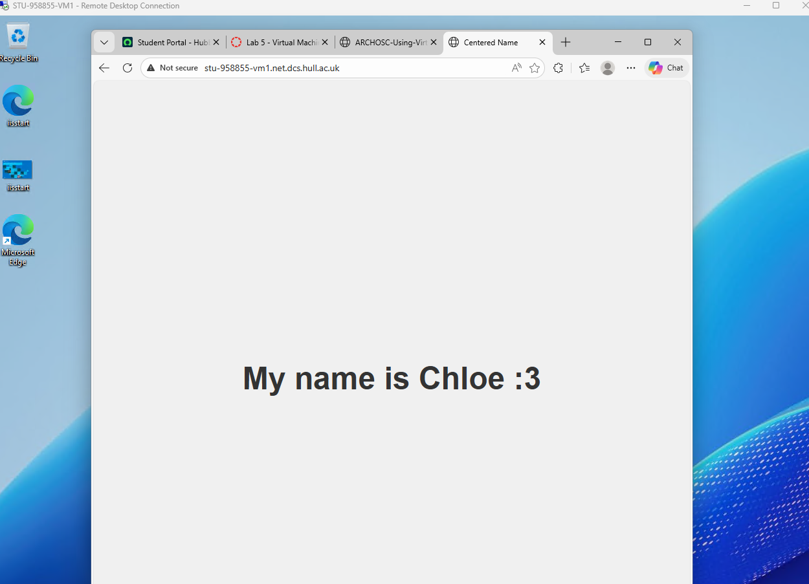
Following the steps from earlier, I created a second virtual machine so that I could use it as my "development" machine.
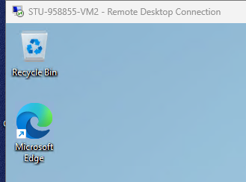

So that I could make changes on my website, I used this website https://code.visualstudio.com/docs/?dv=win64user to install Visual Studio Code. I then got it all set up so that it was ready to use.

I then made a minor change to my website on the second VM, to show that changes on that one would not affect my website on the first VM.
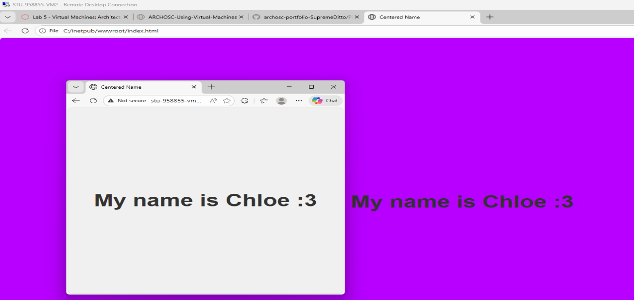
03/03/26 Lab
Firstly, I opened my first virtual machine and opened the command prompt and typed in the command "ipconfig" to get the machine's IPv4 address to use for later.
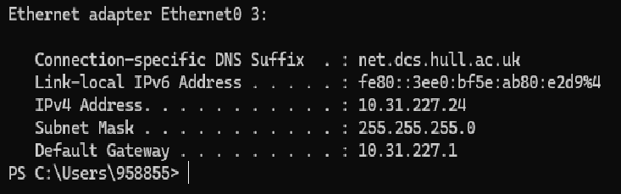

I then did the same thing when I opened my second virtual machine to get its IPv4 address.
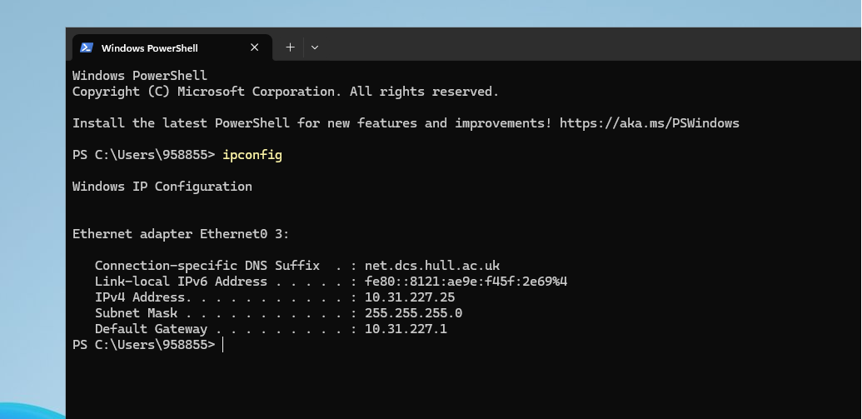

Going back to the first VM, I used the command "Ping [vm2 address]"* to ping my second VM so that they could communicate with each other. I did the same thing with my second VM to make sure that they were communicating properly.
*[vm2 address] is where you put the second VM's IPv4 address

VM1 pinging VM2
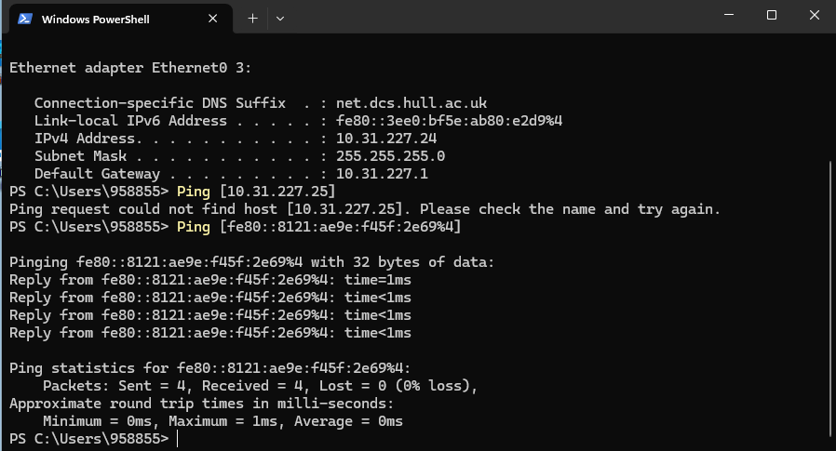

VM2 pinging VM1
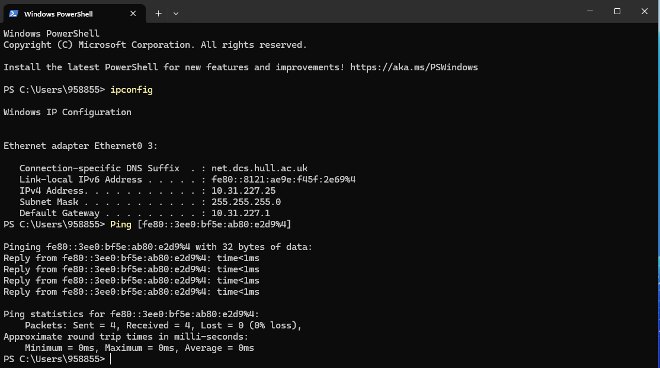

Then, I needed to set up a GitHub runner. I clicked on where it said, "New self-hosted runner" and the GitHub Actions runner registration popped up.
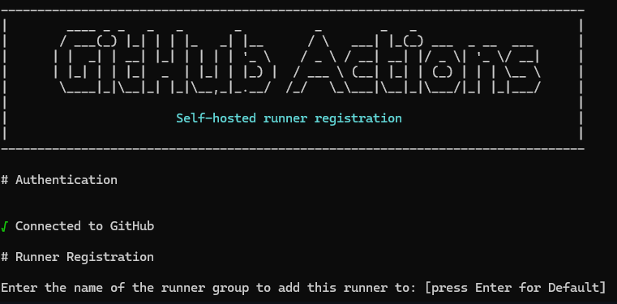

I followed the instructions listed below then it started "listening for Jobs".
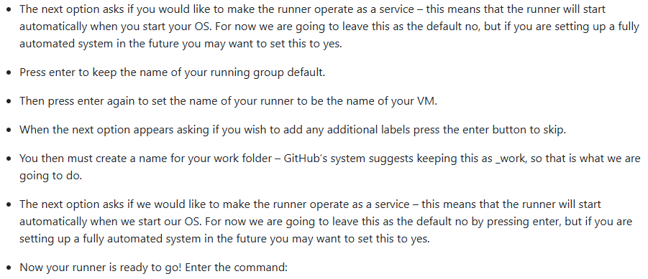

I then wrote out some YAML to use for later.
